**PROIECT CIA\_Documentatie**

**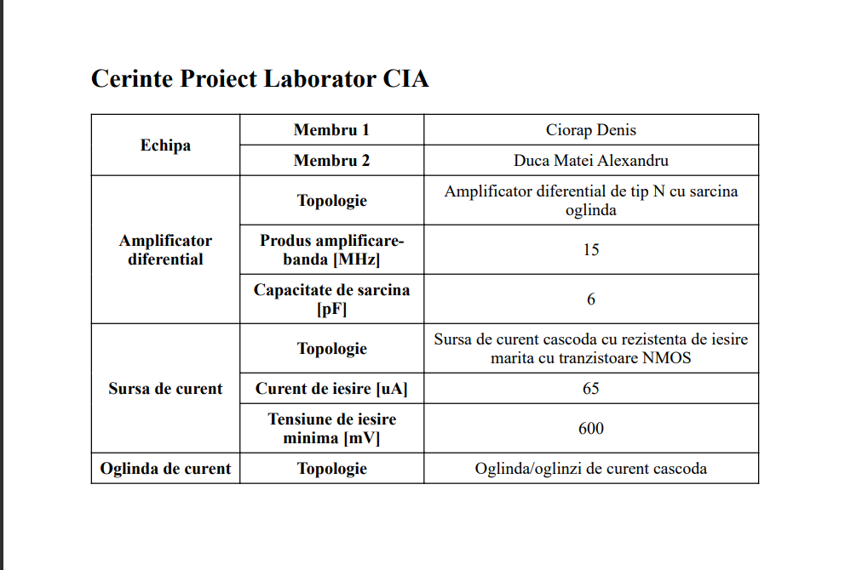**

**SURSA DE CURENT CASCODA CU REZISTENTA DE IESIRE MARITA CU TRANZ. NMOS**

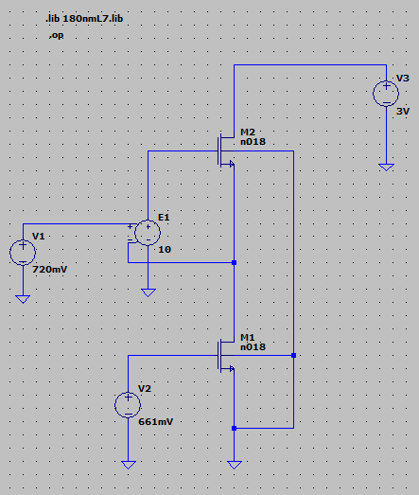

**Inainte de ajustare:**

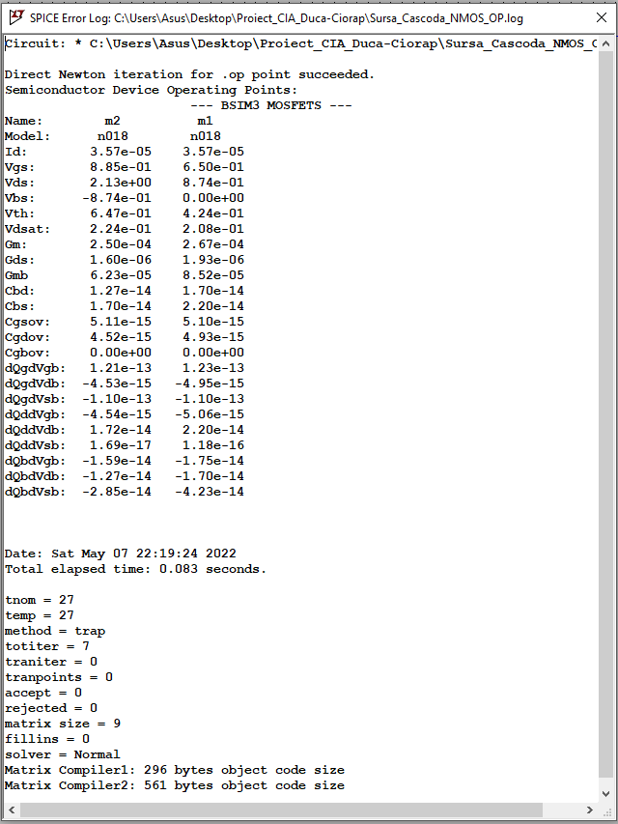

**DUPA AJUSTARE**

|  |  |  |  |  |  |  |  |  |
| --- | --- | --- | --- | --- | --- | --- | --- | --- |
| Tranzistor | ID[uA] |  | VDSAT[mV] | L[um] | W[um] | AD,AS[pm2] | PD,PS[um] | m |
| Mn | 65 |  | 200 | 1.87u | 19.02130u | 1.87p | 19.2u | 1 |

// aici am ghresit la inceputul proiectului si ne-am dat seama abia in ziua in care trebuia sa trimitem

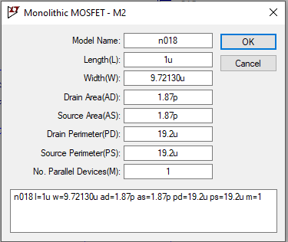

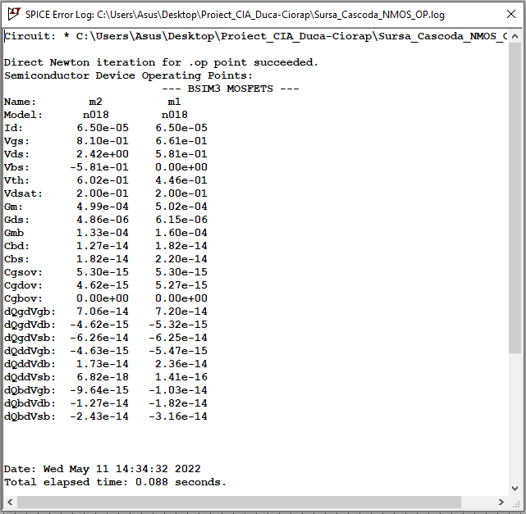

**Calcule Sursa :**

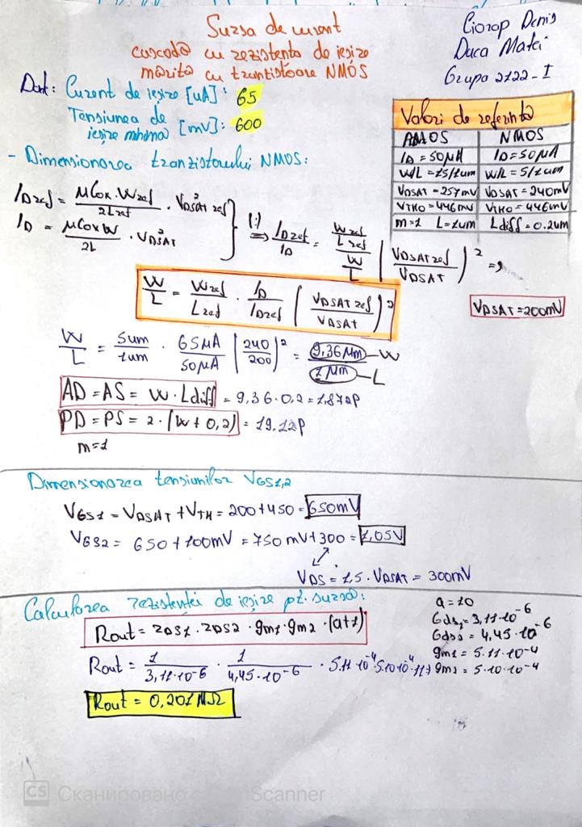

**Rezistenta de iesire pt sursa:**

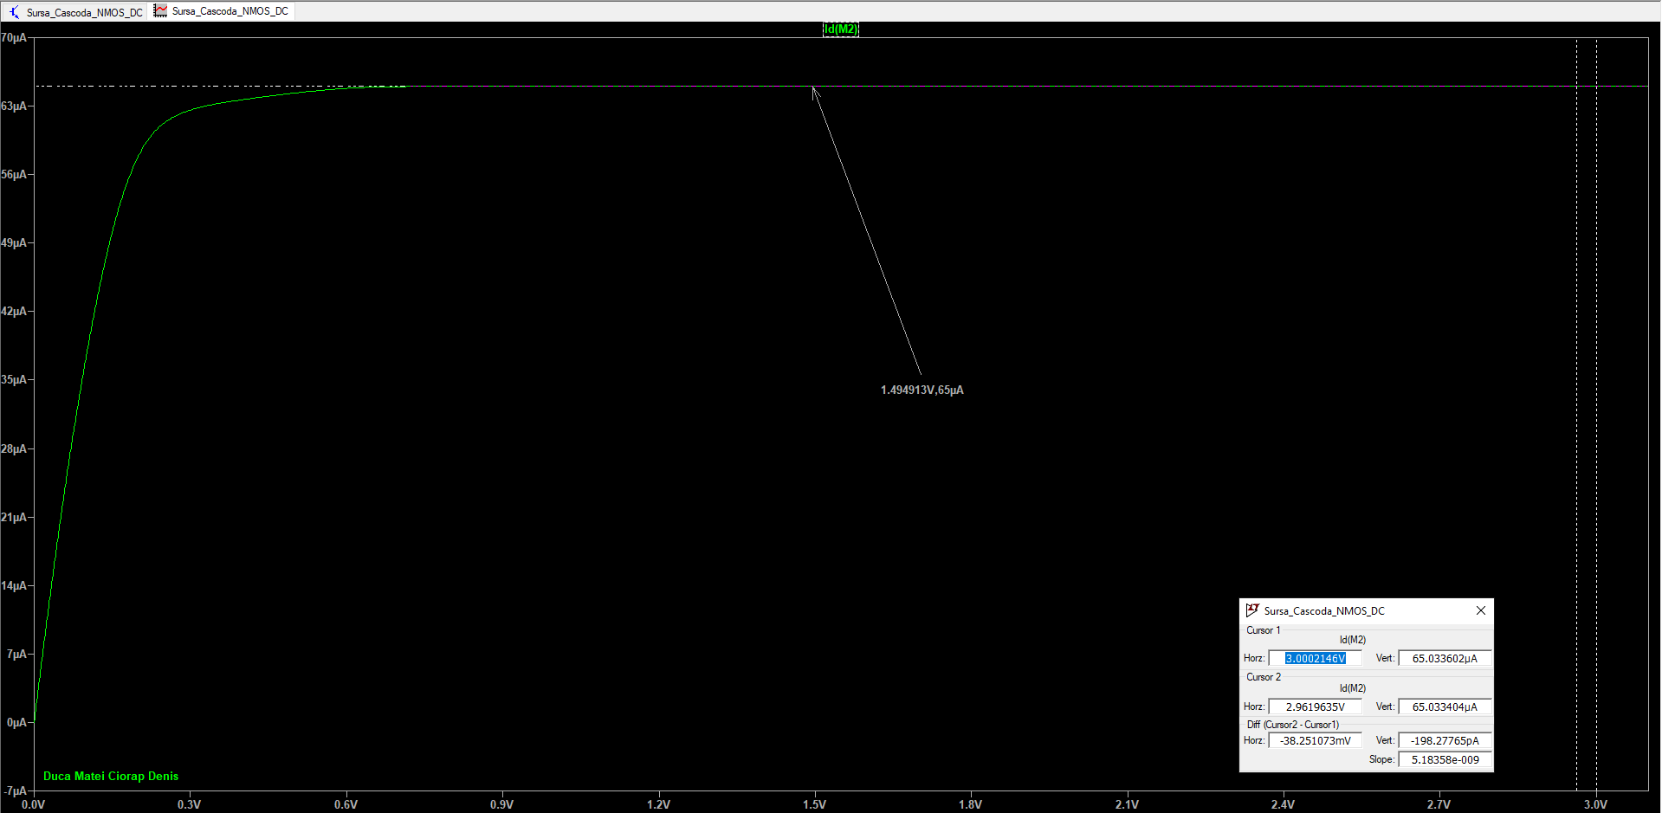

|  |  |  |
| --- | --- | --- |
| Parametru | Calculata | Masurat |
| Rout[MΩ] | 0.20 | 1/5.18=0.19 |

**OGLINDA CASCODA**

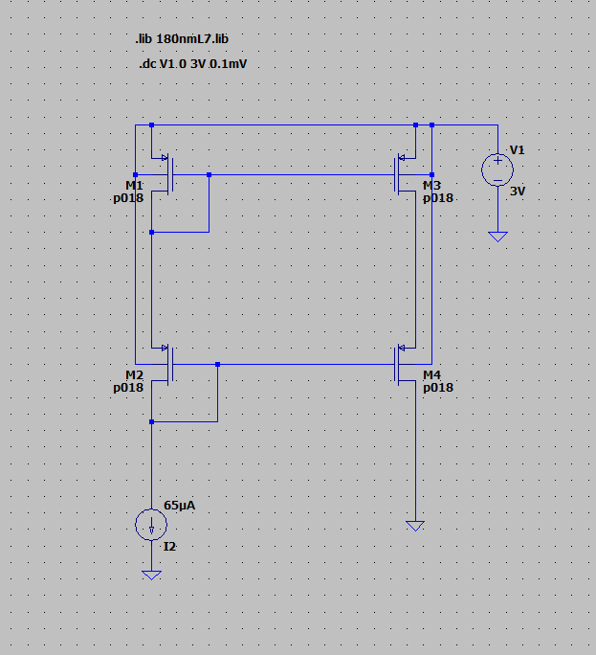

**Inainte de ajustare**

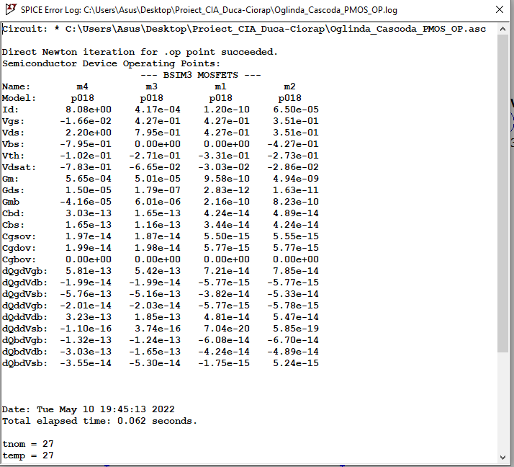

**Calcule Tranzistoare :**  
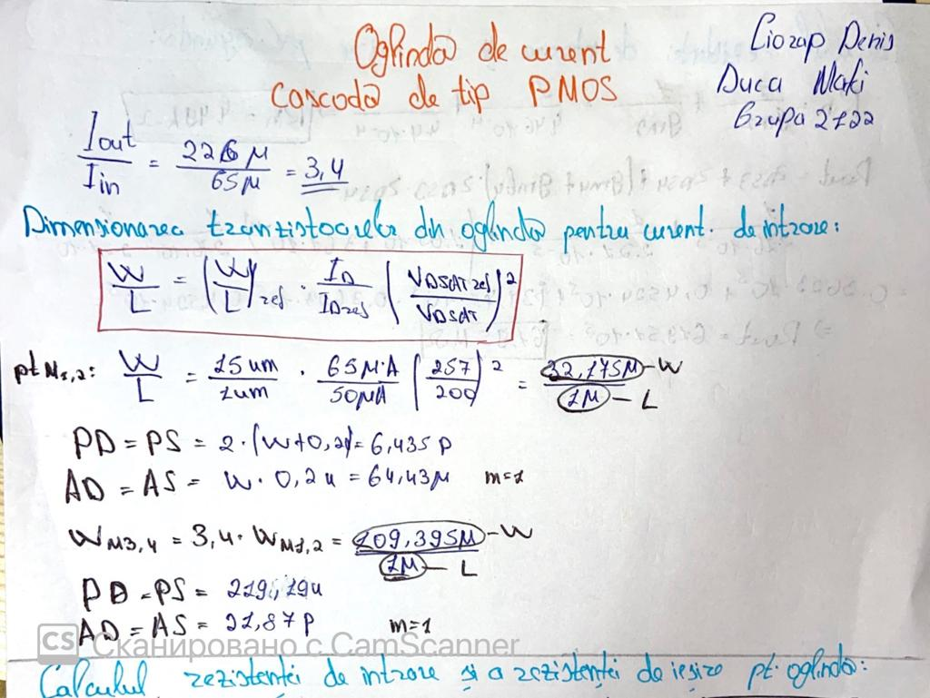

**Dupa ajustare**

|  |  |  |  |  |  |  |  |
| --- | --- | --- | --- | --- | --- | --- | --- |
| Tranzistor | ID[uA] | VDSAT[mV] | L[um] | W[um] | AD,AS[pm2] | PD,PS[um] | m |
| M1 | 65 | 200 | 1 | 32.175u | 6.43p | 21.87p | 1 |
| M2 | 65 | 200 | 1 | 32.175u | 6.43p | 21.87p | 1 |
| M3 | 226 | 200 | 1 | 111.595u | 64.43u | 219.19u | 1 |
| M4 | 226 | 200 | 1 | 111.595u | 64.43u | 219.19u | 1 |

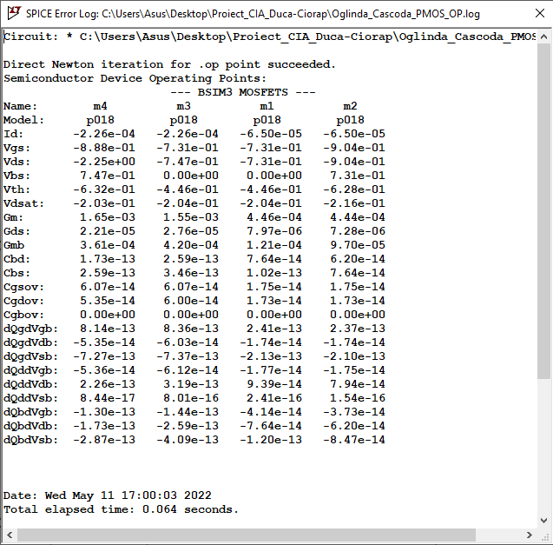

**Calcul Ro si Rin pt oglinda:**

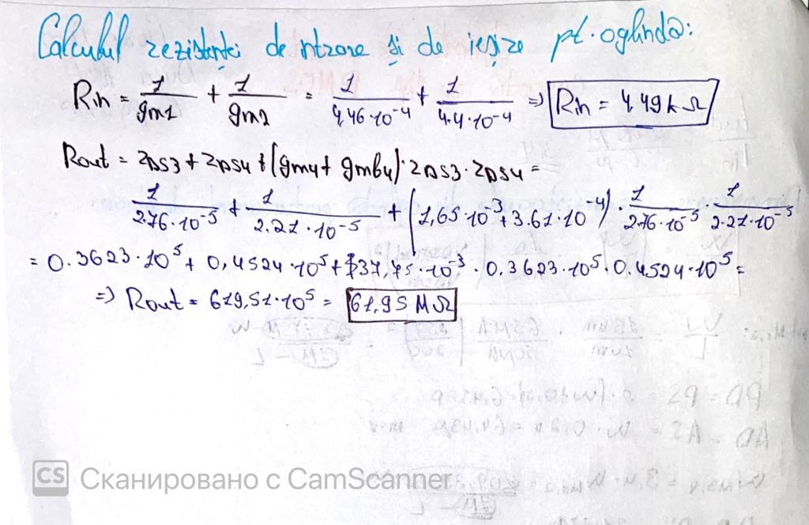

**Rezistenta de INTRARE :**

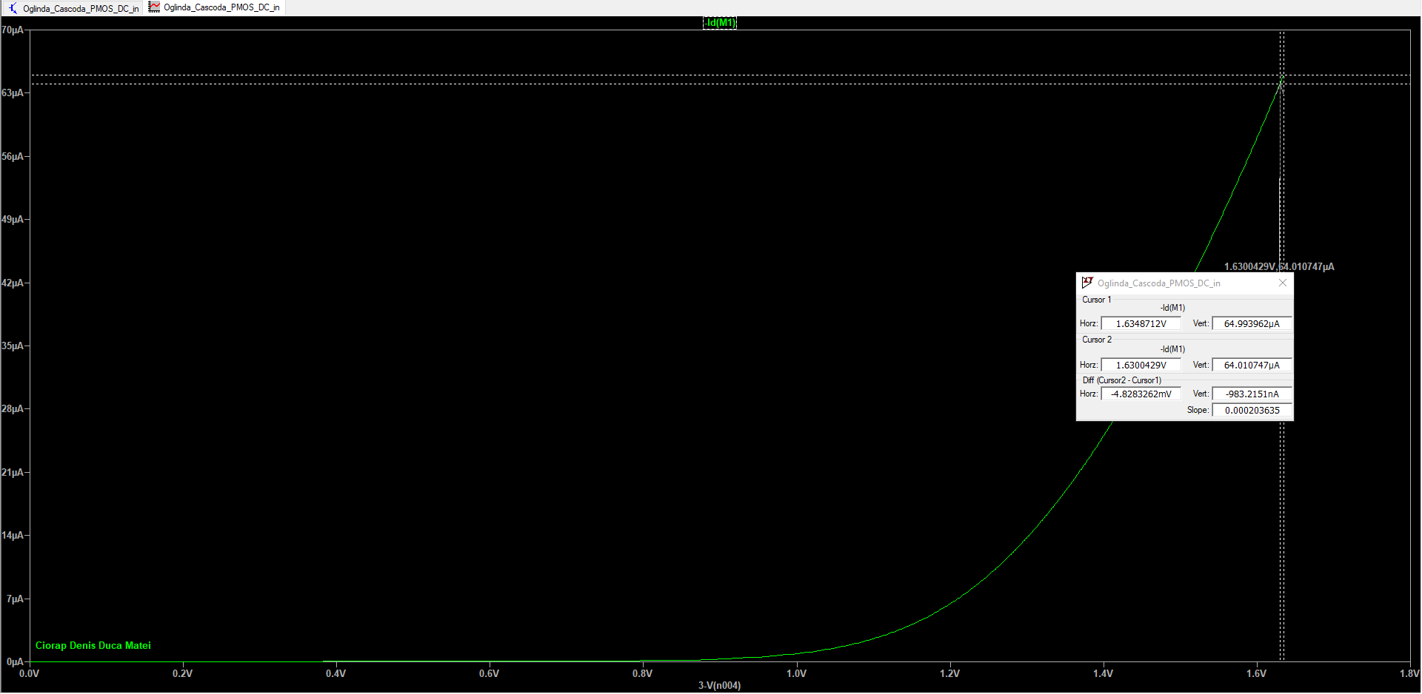

**Rezistenta de IESIRE :**

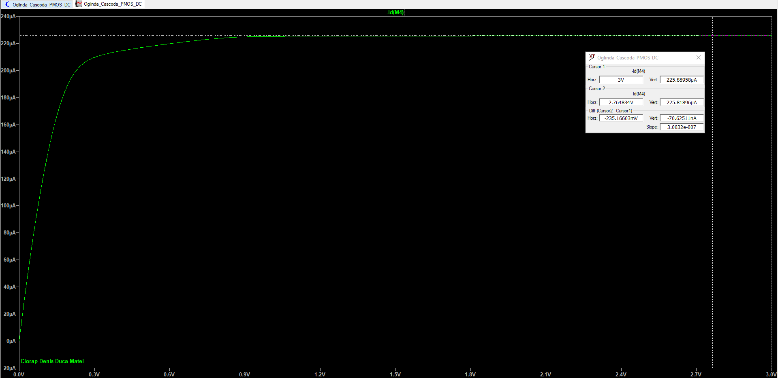

|  |  |  |
| --- | --- | --- |
| *Parametru* | *Calculat* | *Masurat* |
| *Rin* | *4.49K* | *4.9K* |
| *Rout* | *61.95M* | *33.33M* |

**Oglinda cascoda export iesire**C:\Users\Asus\AppData\Local\Microsoft\Windows\INetCache\Content.Word\Oglinda_Cascoda_PMOS_DC_EXPORT.EMF

**AMPLIFICATOR DIFERENTIAL DE TIP N CU SARCINA OGLINDA**

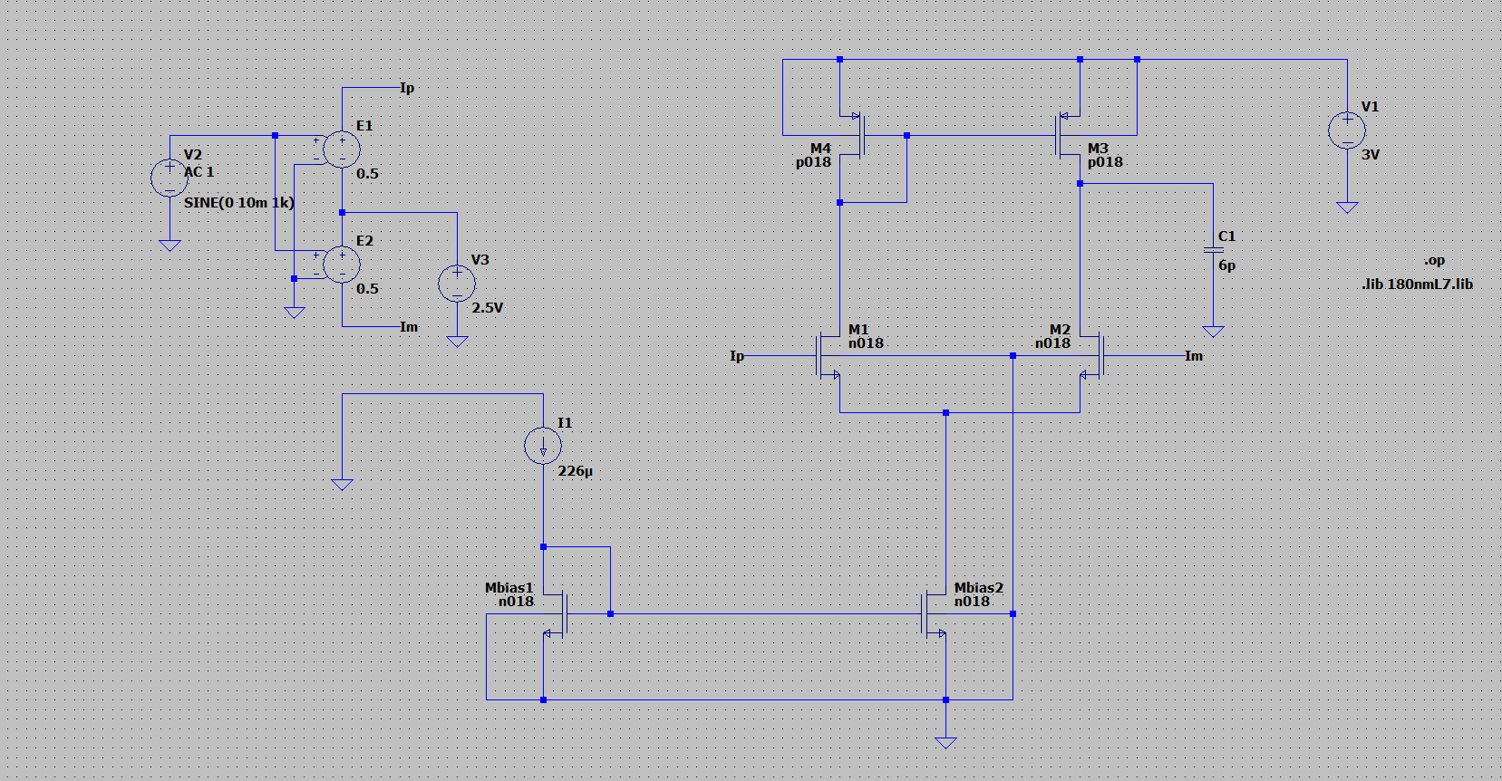

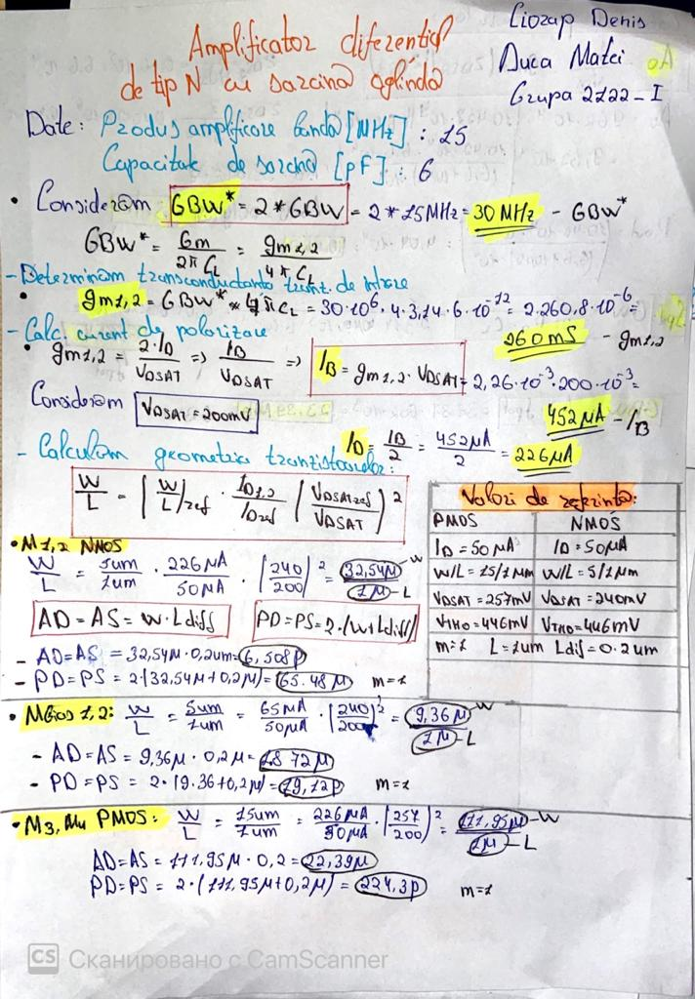

**Inainte de ajustare**

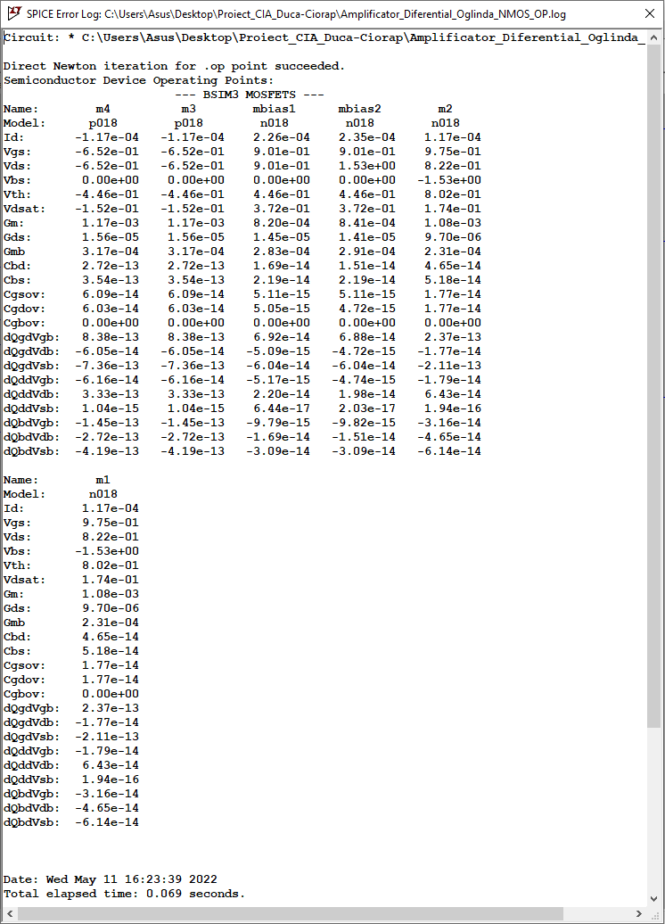

**Dupa ajustare**

|  |  |  |  |  |  |  |  |
| --- | --- | --- | --- | --- | --- | --- | --- |
| Tranzistor | ID[uA] | VDSAT[mV] | L[um] | W[um] | AD,AS[pm2] | PD,PS[um] | m |
| M1 | 1.13 | 200 | 1 | 24.94u | 6.5p | 65.48u | 1 |
| M2 | 1.13 | 200 | 1 | 24.94u | 6.5p | 65.48u | 1 |
| M3 | 1.13 | 200 | 1 | 62.95u | 22.39p | 224.3u | 1 |
| M4 | 1.13 | 200 | 1 | 62.95u | 22.39p | 224.3u | 1 |
| Mbias1 | 2.26 | 200 | 1 | 33.36u | 1.872p | 35.12u | 1 |
| Mbias2 | 2.26 | 200 | 1 | 33.36u | 1.872p | 35.12u | 1 |

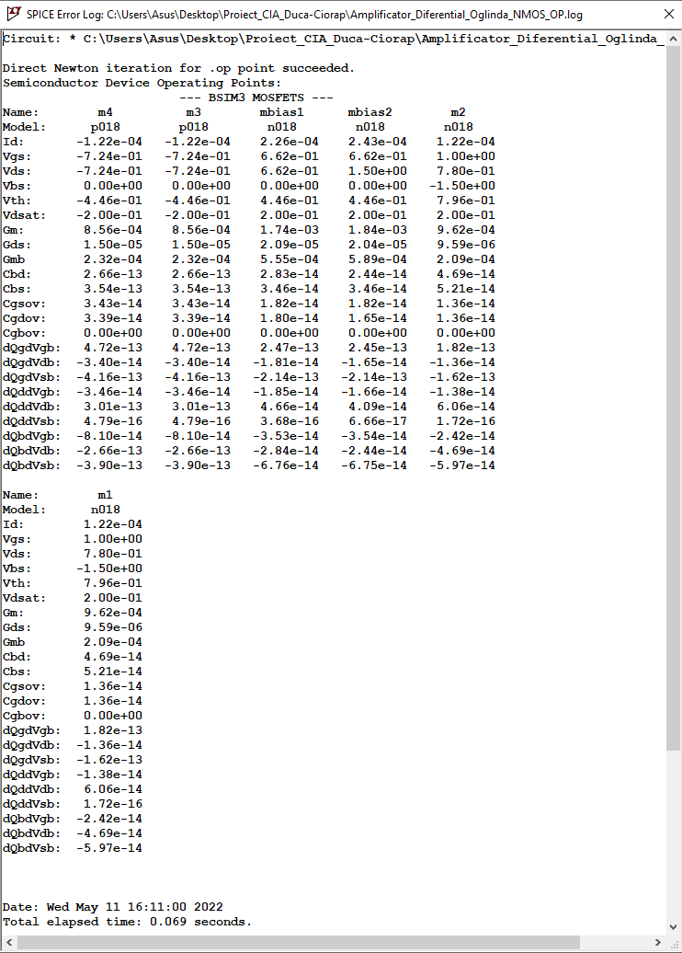

**

**Masurare AO**

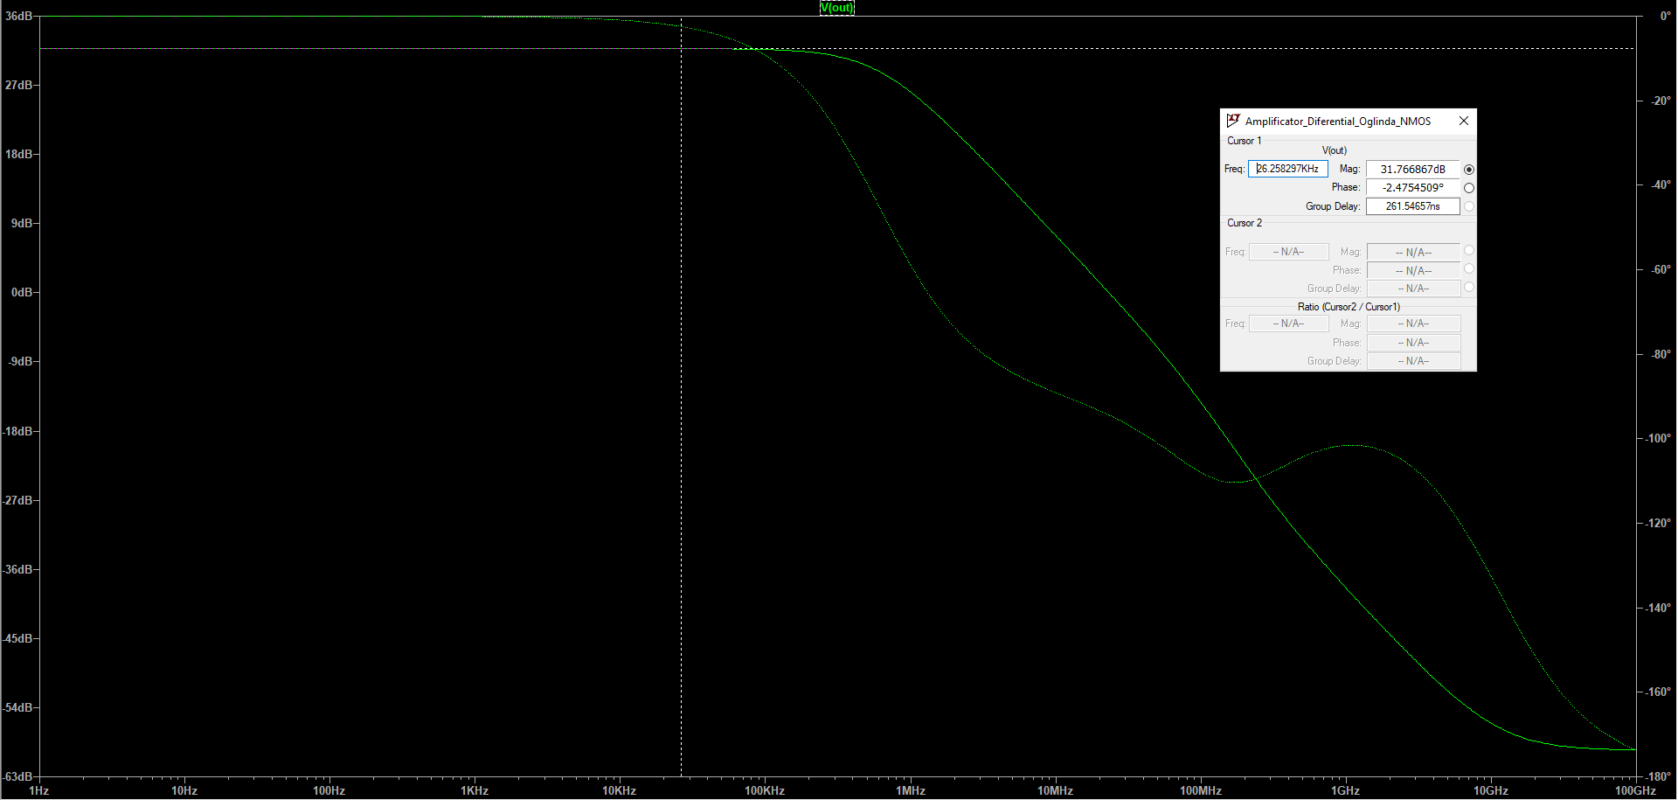

**Masurare GBW**

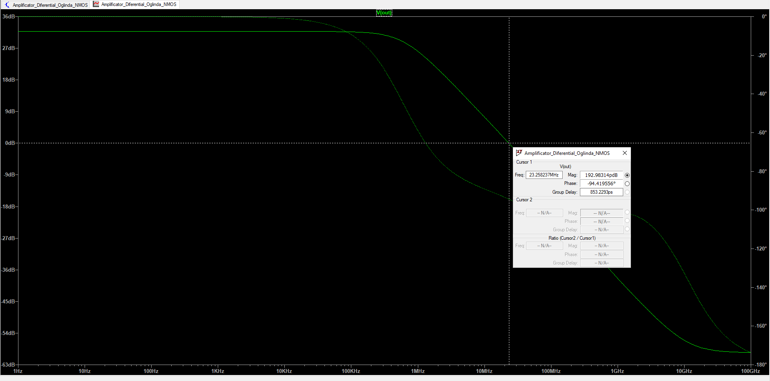

**Masurare Fp**

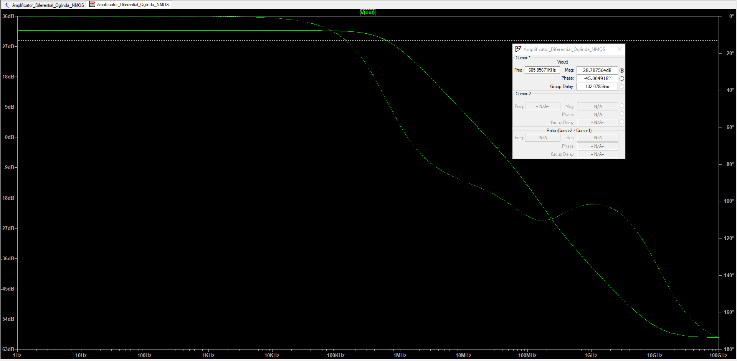

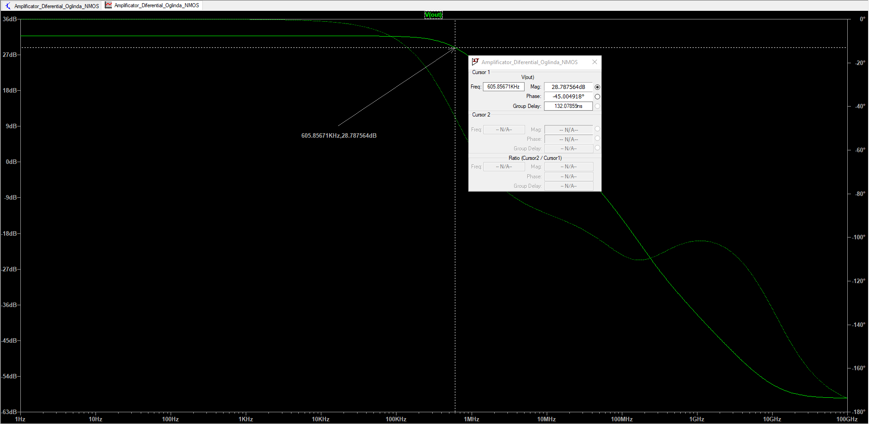

**Notes and Annotations**

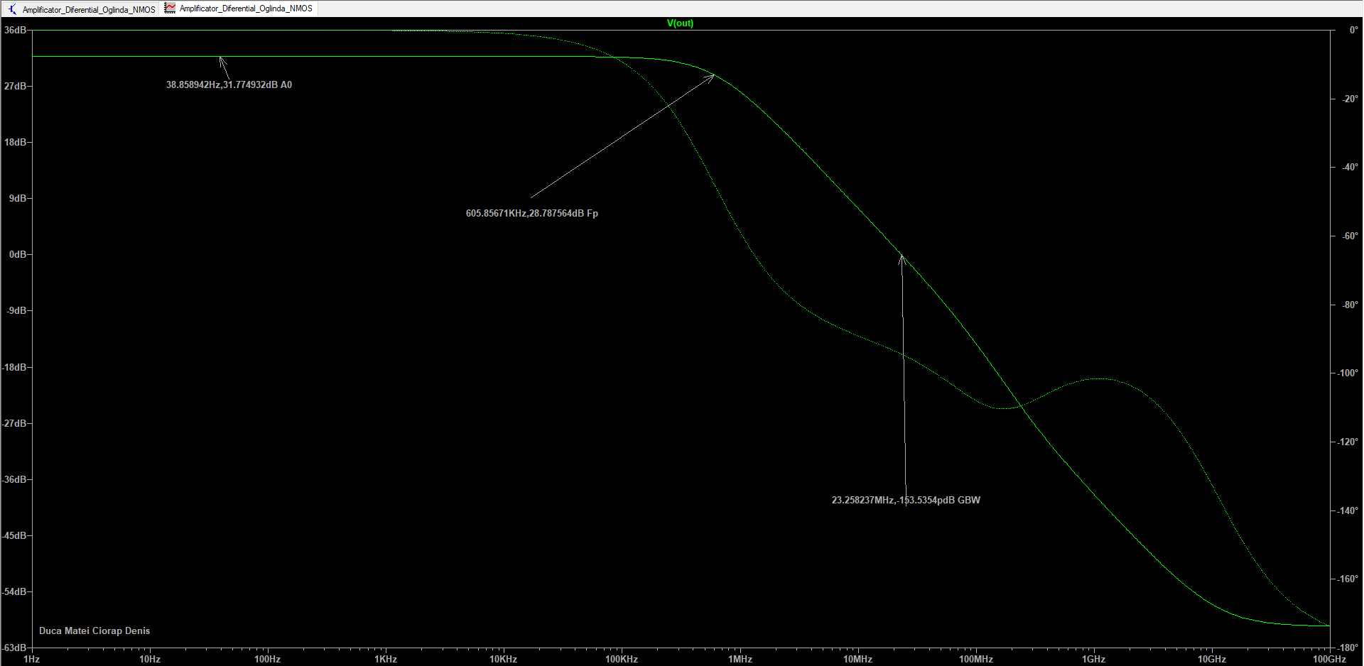

* **Tabel cu valori calculate si masurate al parametrilor amplificatorului diferential**

|  |  |  |
| --- | --- | --- |
| Parametru | Calculat | Masurat |
| A0[dB] | 31 dB | 31.7dB |
| Fpol/GW[kHz} | 602kHz | 60585 |
| GBW[MHz] | 23.39M | 23.25M |

***CIRCUIT FINAL***

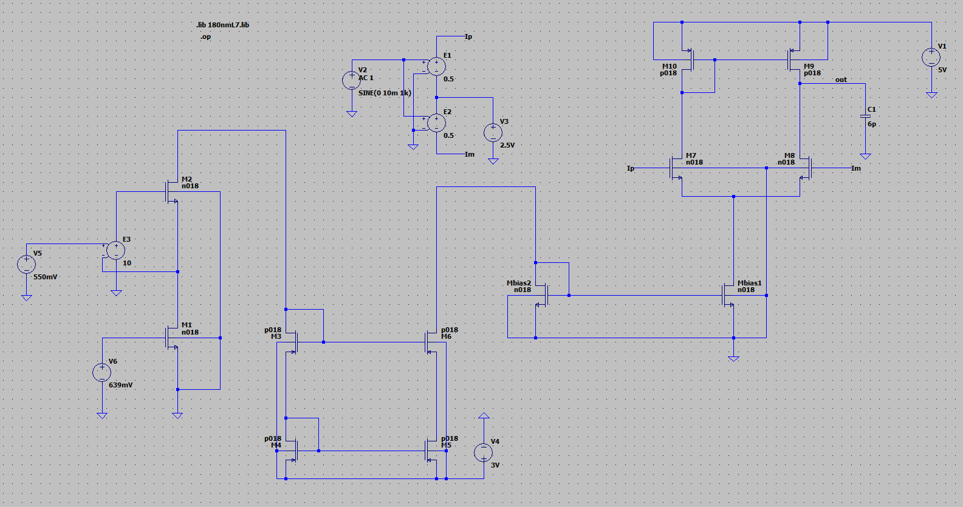

**INAINTE DE AJUSTARE**

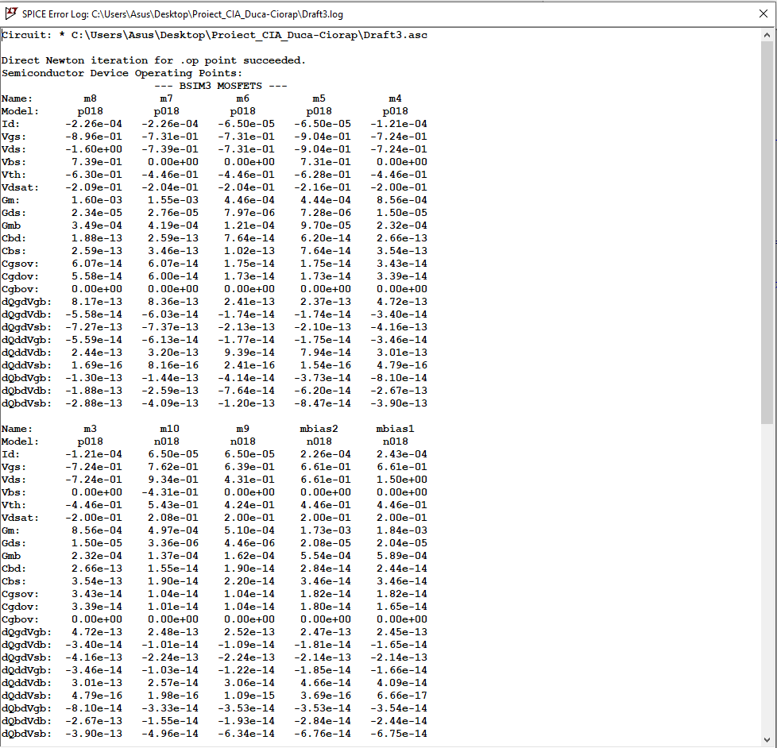

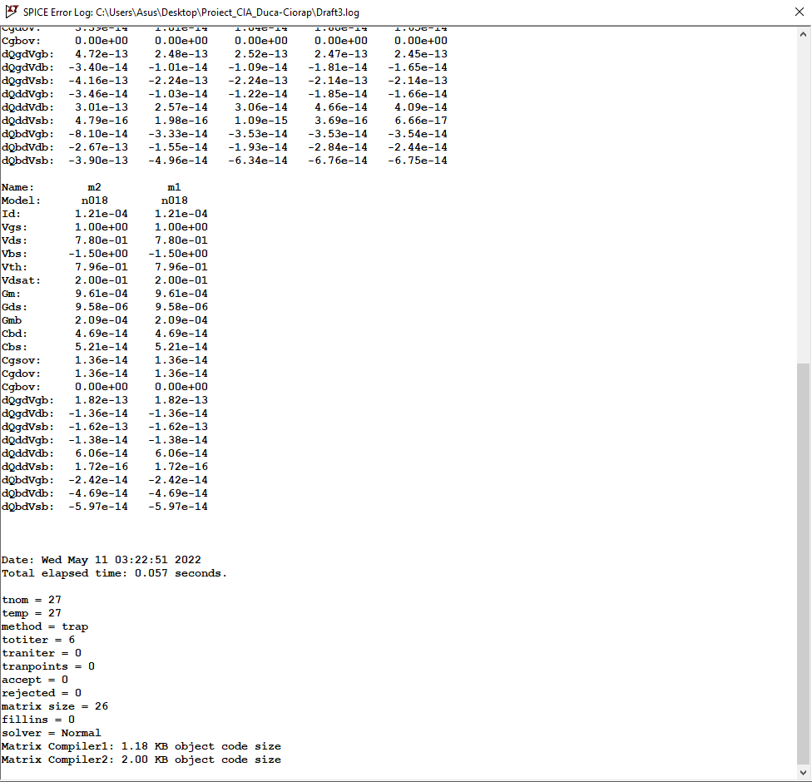

**DUPA AJUSTARE**

